Creating account on GitHub

**Step1:** Go to the official website of GitHub - <https://github.com/>



**Step2:** Now click on the signup button at top corner at right and complete the signup

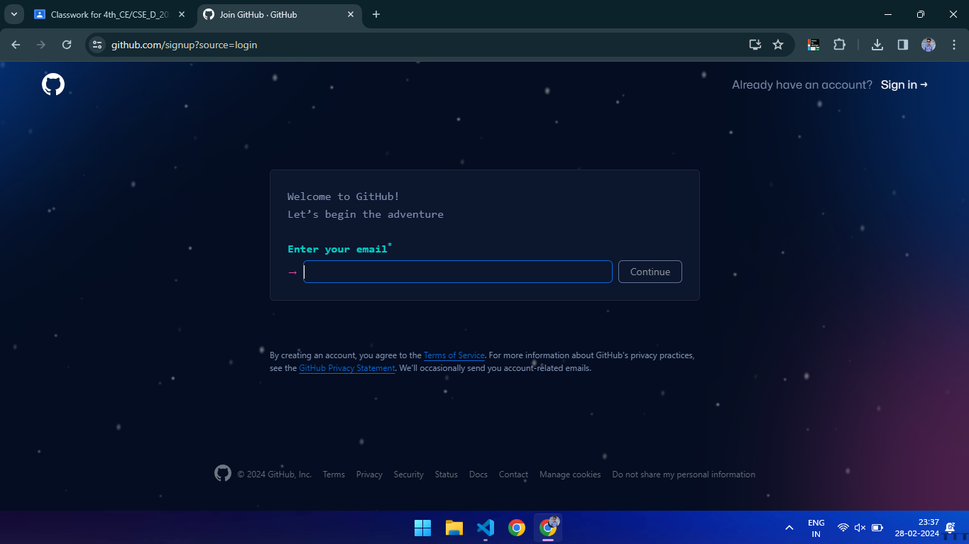

**Step3:** After completing the signup go to the your profile section

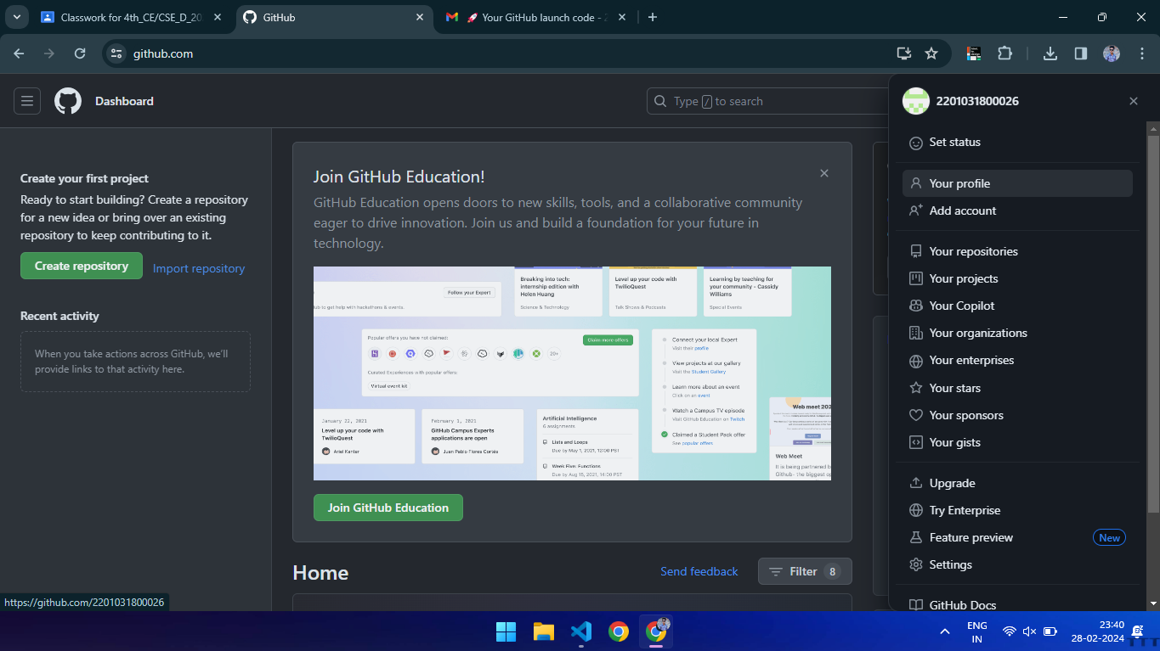

**Step4:** In profile section on top right there’s a plus sign. Go there and click on create a git repository.

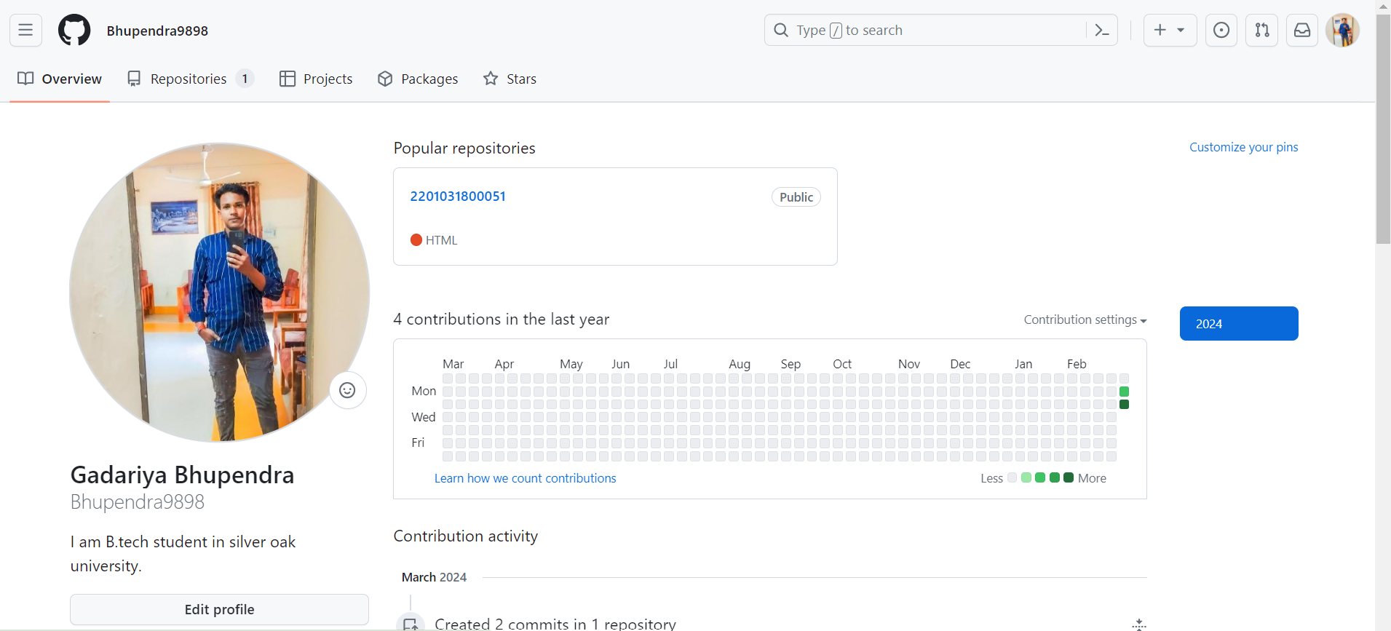

**Step5:** After clicking on new repository Give the name and description to your repo. Keep the repository public.

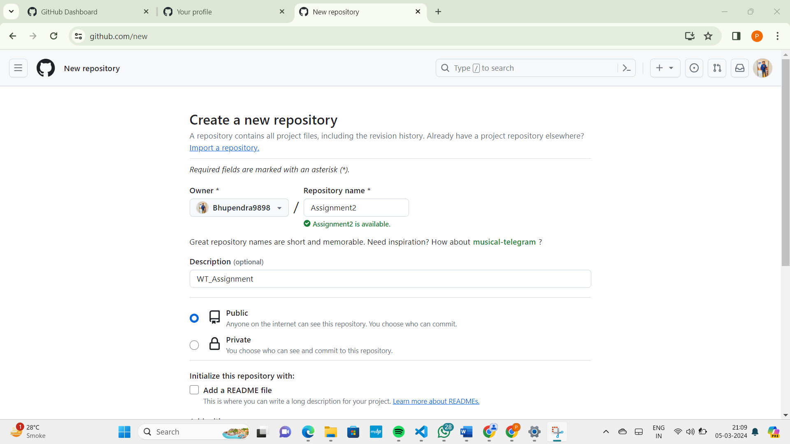

After giving name and description click on Create Repository.

**Step6:** Goto your created repository and click on add file option.

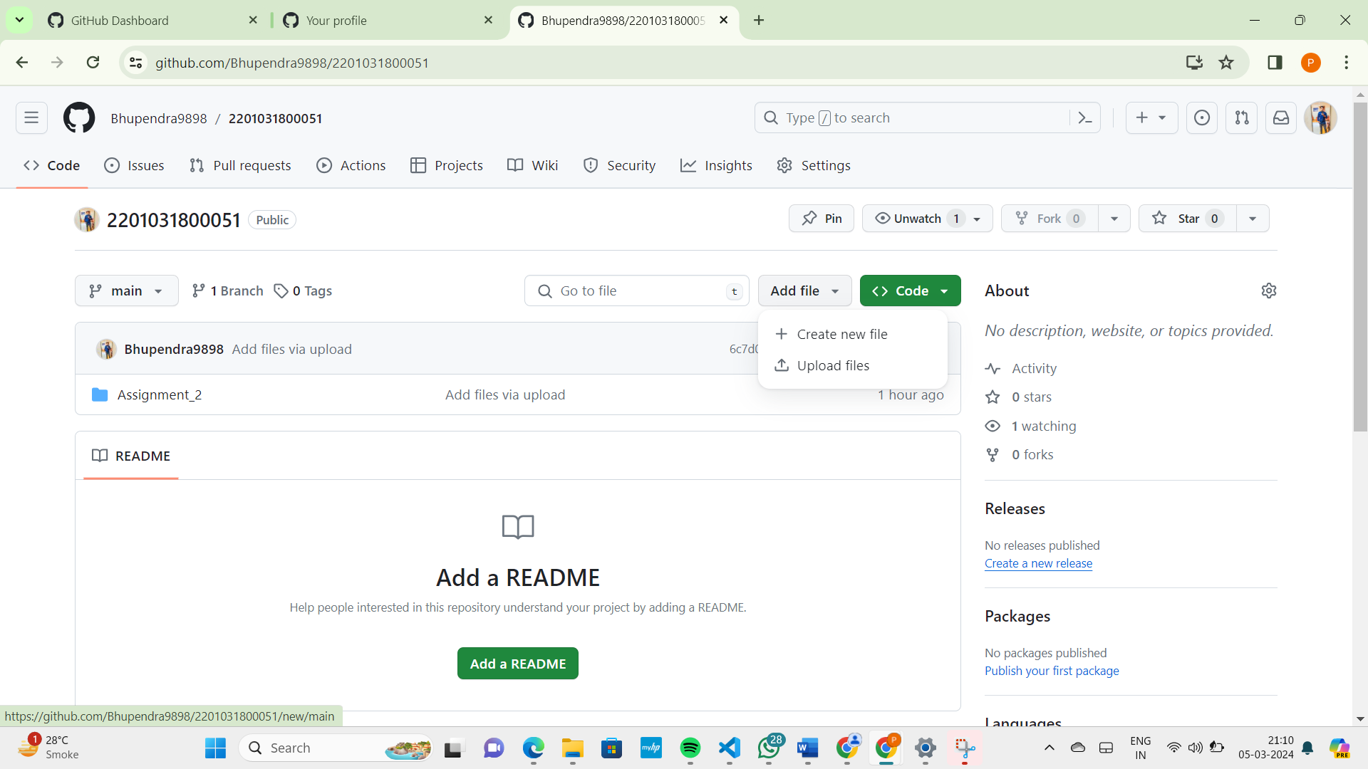

After clicking on it create new file and give the name Assginment_1/

And create second one and give it to name Assignment_2/ [**note:** ‘**/**’ after file name converts ours file name into and folder

**Step7:**  After naming the assignment_1/ got to that folder and click on Upload file using drag and drop and click on Commit changes.

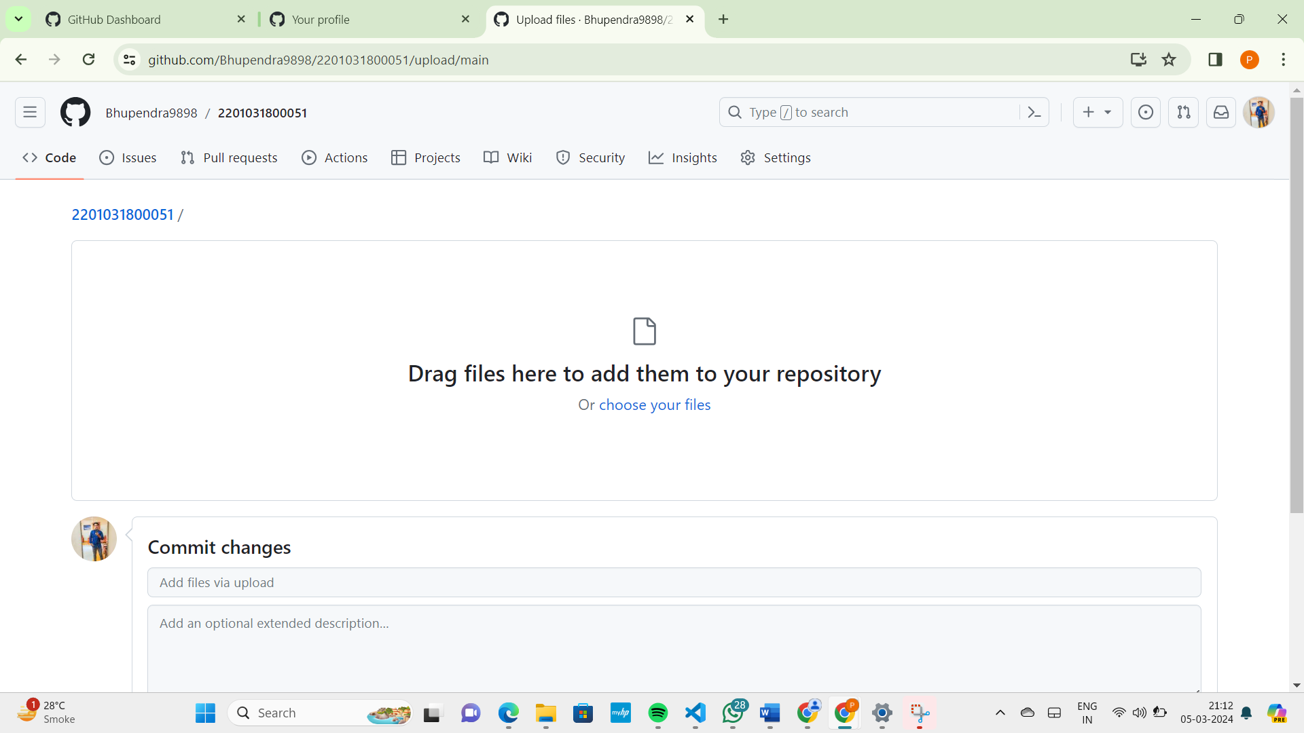

Done. Your git repo’s are created and Asssignment_1 Completed